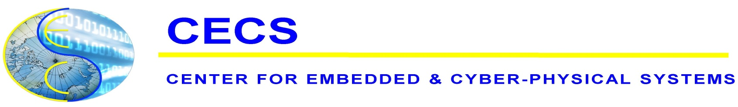
CECS Mini Tutorial Series
present
"Cyber-Physical Systems: Opportunities, Problems and (Some) Solutions"

Dr. Peter Marwedel
Technical University of Dortmund, Germany
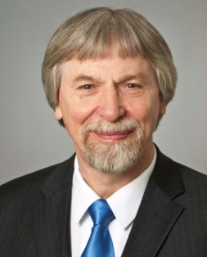
Abstract: The term “cyber-physical systems” characterizes the integration of information and communication technologies (ICT) with their physical environment. This integration results in a huge potential for the development of intelligent systems in a large set of industrial sectors. The potential will be covered in the first part of the talk. Sectors comprise industrial automation (“industry 4.0”), traffic, consumer devices, the smart grid, the health sector, urban living and computer-based analysis in science and engineering. A multitude of goals can be supported in this way, e.g., the availability of higher standards of living, higher efficiency of many processes, the generation of knowledge and safety for the society. However, the realization of this integration implies manifold challenges. Challenges covered in the second part of this talk include security, timing, safety, reliability, energy efficiency interfacing, and the discovery of information in huge amounts of data. Also, the inherent multidisciplinarity poses challenges for knowledge acquisition and application. In the third and final part of the talk, we will present some of our contributions addressing these issues. These contributions include real-tine virus detection using an advanced sensor, resource-aware mapping of machine-learning applications to multi-cores, an integration of a timing model into the code generation process, techniques for improving the energy efficiency of CPS applications, tradeoffs between timeliness and reliability and approaches for education crossing boundaries of involved disciplines.

Biography: Dr. Peter Marwedel studied physics at the University of Kiel, Germany. He received his PhD in physics in 1974. As a post-doc, he published some of the first papers on high-level synthesis and retargetable compilation in the context of the MIMOLA hardware description language. In 1987, his habilitation thesis in computer science was accepted. He worked as a professor for computer engineering at TU Dortmund since 1989. He is chairing ICD, a local spin-off of TU Dortmund. His research interests include design automation for embedded systems, in particular the generation of efficient embedded software. Focus is on energy efficiency and timing predictability. Dr. Marwedel published papers on energy-efficient and timing-predictable software, including compiler-supported use of scratchpad memories. He is the author of one of the few textbooks on embedded systems. The book is complemented by videos available on youtube and by publicly available slides. He served as the vice-chair of the collaborative research center SFB 876, aiming at resource-efficient analysis of large data sets since 2011. Dr. Marwedel is an IEEE Fellow. He received the EDAA Lifetime Achievement Award in 2013 and the ESWEEK Lifetime achievement award in 2014.

Thursday, February 4, 2016, 2:00-4:00pm
Engineering Hall 2430
Host: Prof. Fadi Kurdahi

