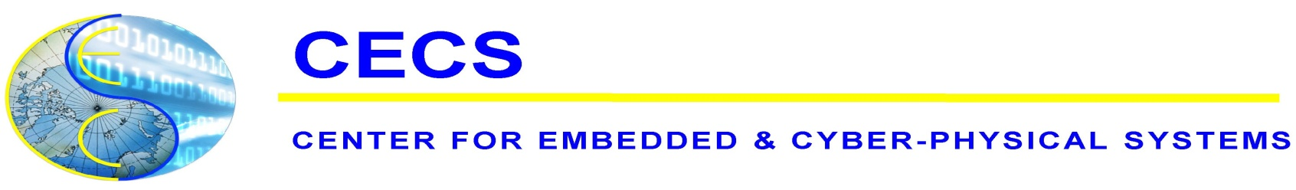
CECS Seminar Series
Presents
"Design Automation of Things: Power Consumption Characterization, Modeling and Estimation of Electric Vehicles"

Professor Naehyuck Chang
Department of Electrical Engineering, Korea Advanced Institute of Science and Technology (KAIST)
Abstract: Rapid electric vehicle (EV) penetration gives a threatening challenge in electric energy generation. An 1,814 kg curb weight full electric vehicle driving 18,129 km/year consumes electricity energy equivalent to 74% of the total residential electricity use per person in the US. This implies that 27% more nationwide electricity generation is needed when 70% of passenger vehicles are replaced with EVs.

This talk introduces the first step toward systematic EV design-time and runtime optimization. We develop instantaneous power consumption modeling of an EV by the curb weights, speed, acceleration, road slope, passenger and cargo weights, motor capacity, and so on, as a battery discharge model. The model also considers the onboard charger, regenerative braking and so on, as a battery charge model. To insure model fidelity, we fabricate a lightweight custom EV, perform extensive measurement, and derive model coefficients using multivariable regression analysis. We estimate the EV instantaneous power consumption of a given speed and route profiles and verify the estimation fidelity with a real test run data. This talk will also cover the on-going project for the next version electric vehicle with four-wheel drive capability.

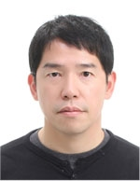
Biography: Naehyuck Chang is a Full Professor with the Department of Electrical Engineering, Korea Advanced Institute of Science and Technology (KAIST). Before he joined KAIST, he was a full professor at Dept. of Computer Science and Engineering, Seoul National University. He also served as a Vice Dean of College of Engineering, Seoul National University. His current research interests include low-power embedded systems and Design Automation of Things such as systematic design and optimization of energy storage systems and electric vehicles.

Naehyuck Chang is the Chair of ACM SIGDA, Editor-in-Chief of the ACM Transactions on Design Automation of Electronics Systems, and General Co-Chair of VLSI-SoC 2015 and Technical Program Chair of ASP-DAC 2015. He was the General Co-Chair of ICCD 2014, ISLPED 2011 and ESTIMedia 2011-2012. He was the Technical Program (Co)-Chair of ICCD 2014, CODES+ISSS 2012, ISLPED 2009, ESTIMedia 2009-2010, etc. He was an Associate Editor of IEEE ESL, IEEE TCAS-I, IEEE TCAD, ACM TODAES, and ACM TECS, Springer DAES, and was a Guest Editor of ACM TODAES in 2010, and ACM TECS in 2010 and 2011. He is a Fellow of IEEE and an ACM Distinguished Scientist.

Tuesday, February 10, 2015 - 2:00pm to 3:00pm
Harut Barsamian Colloquia Room (EH 2430)
CECS Host: Nikil Dutt

